**Assignment 1: Web Basics**

Ambuk Rehani

Department of Information Technology, Arizona State University

IFT 544: Middleware Prog & Database Sec

Prof. Dinesh Sthapit

Aug 27, 2023

**Installation and Setup**

**Visual Studio Code Installation**

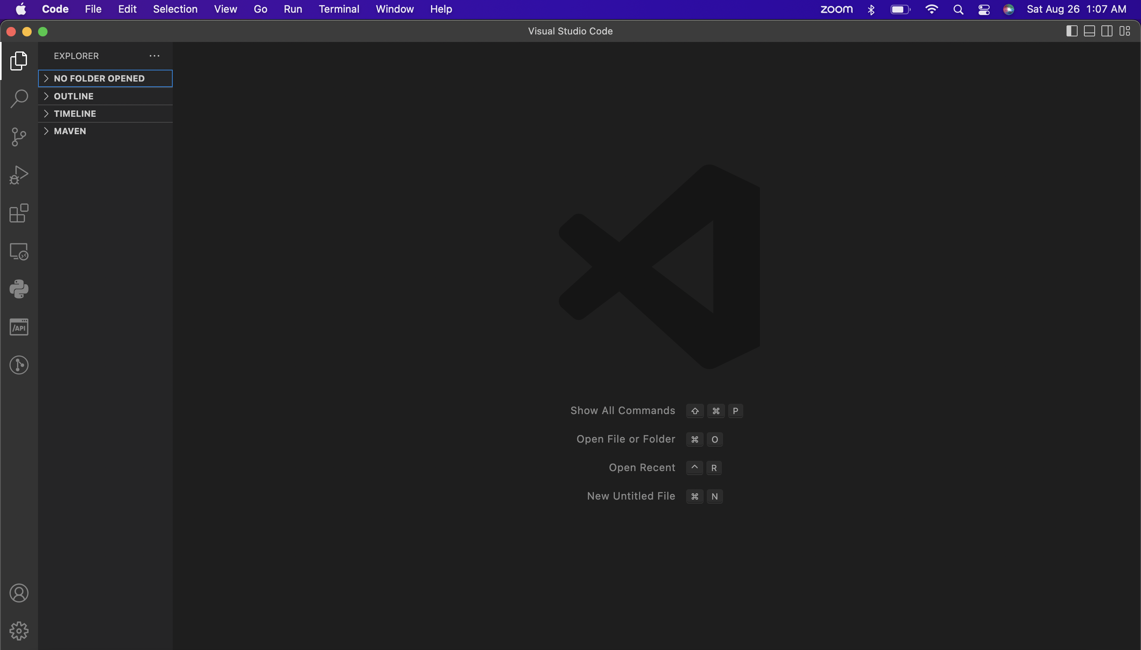

**Node.js Installation**

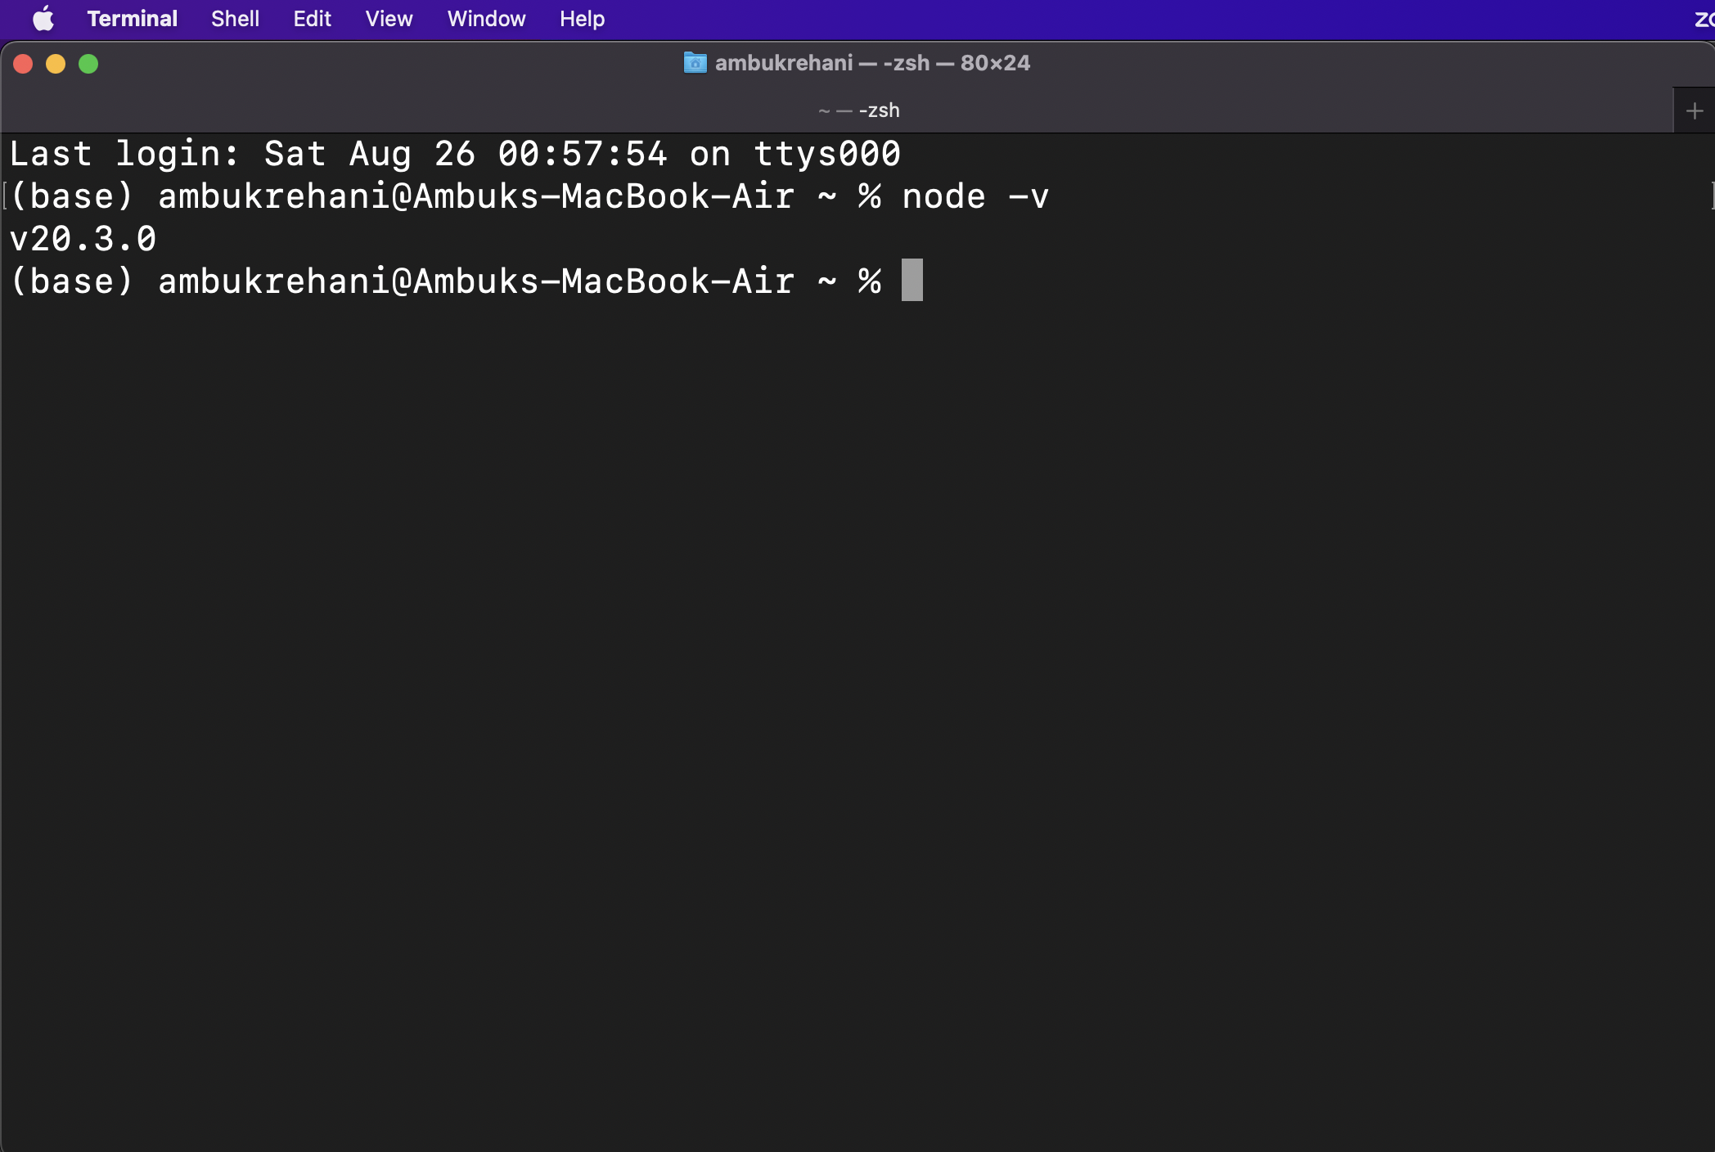

**Express.js Installation**

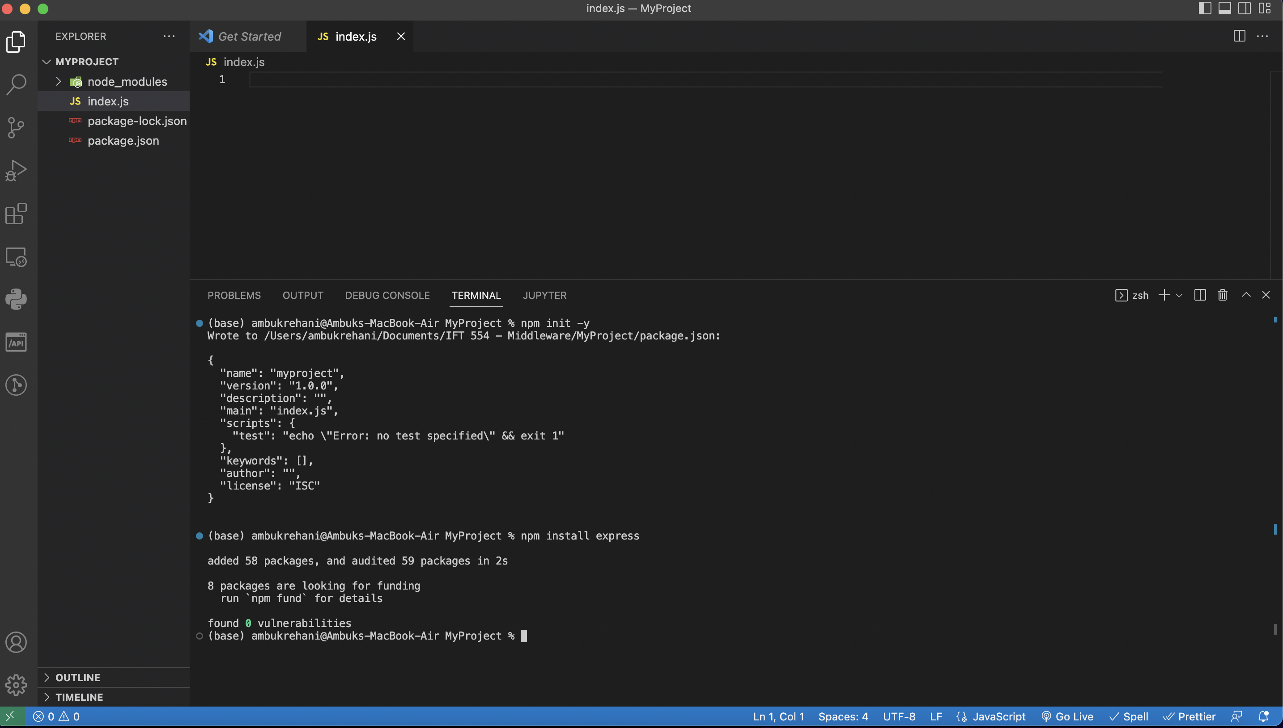

**EJS Installation**

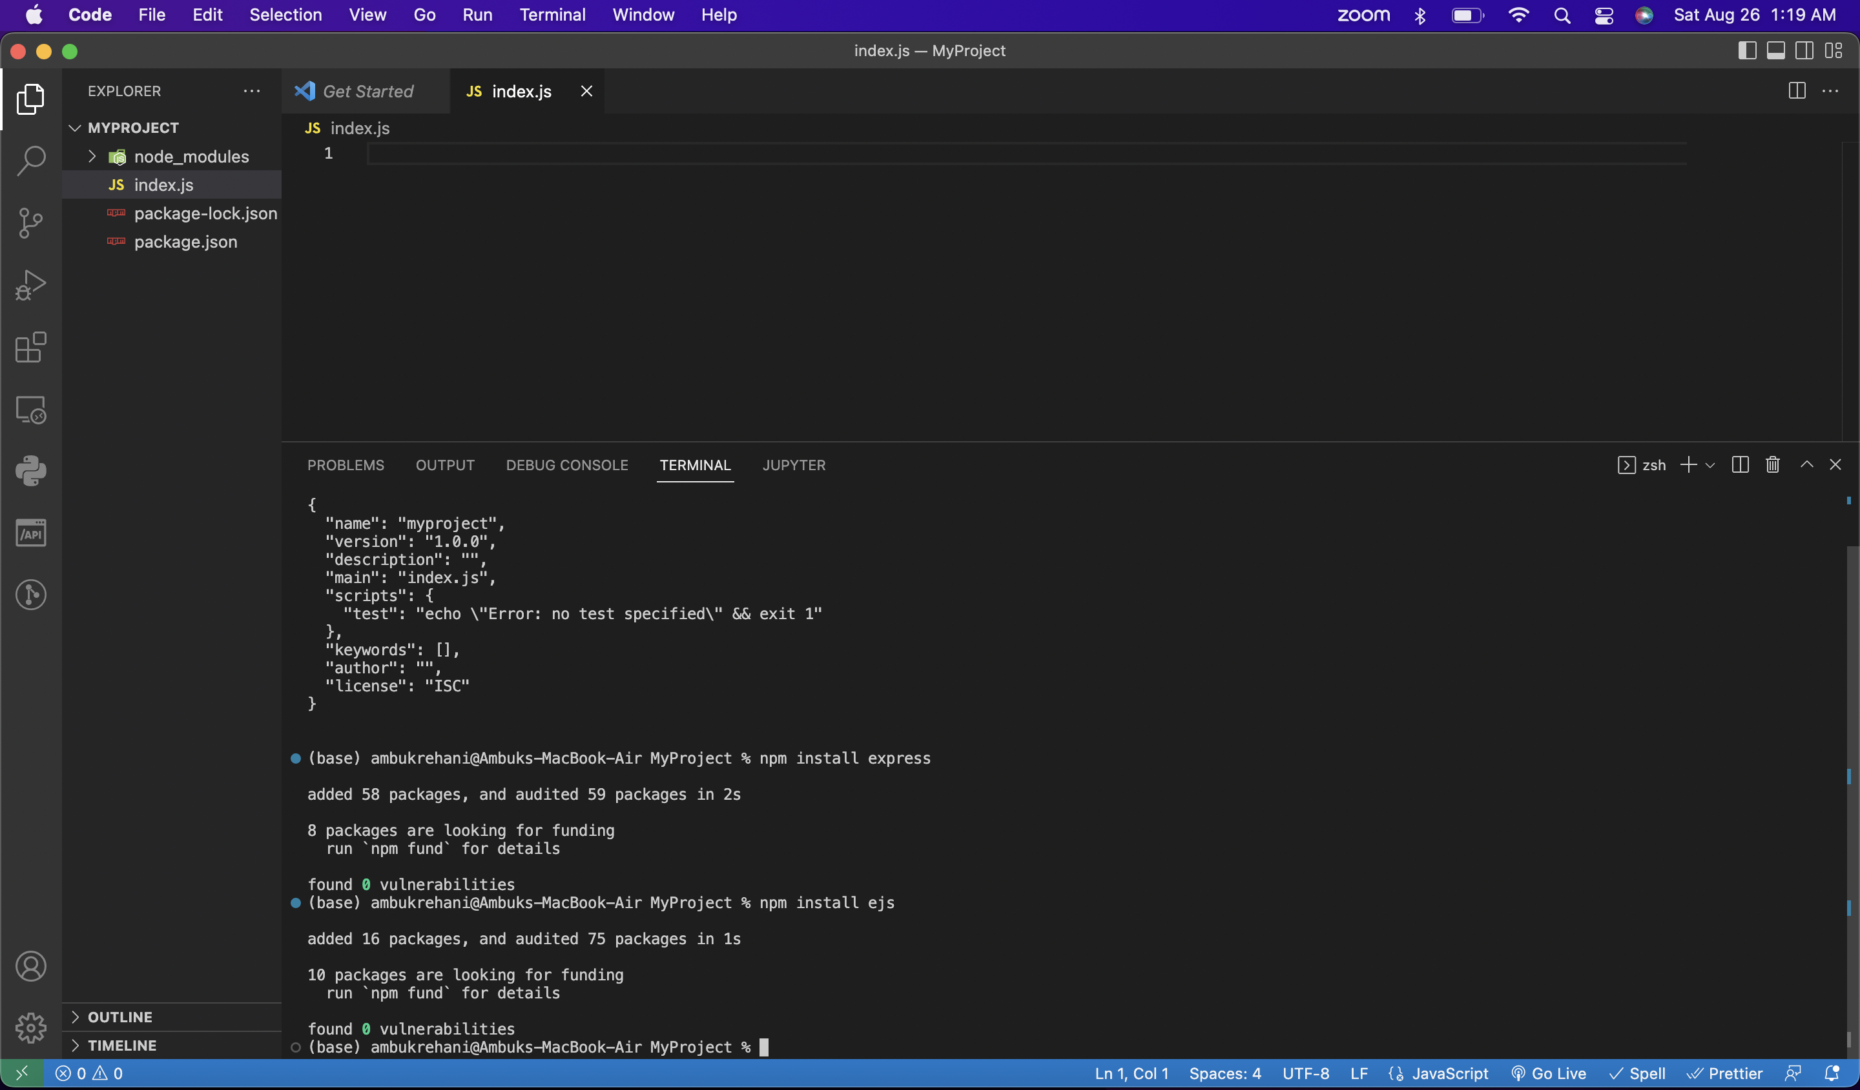

**Working with the Sample Project**

**Step 1: Setup Node.js and Express.js:**

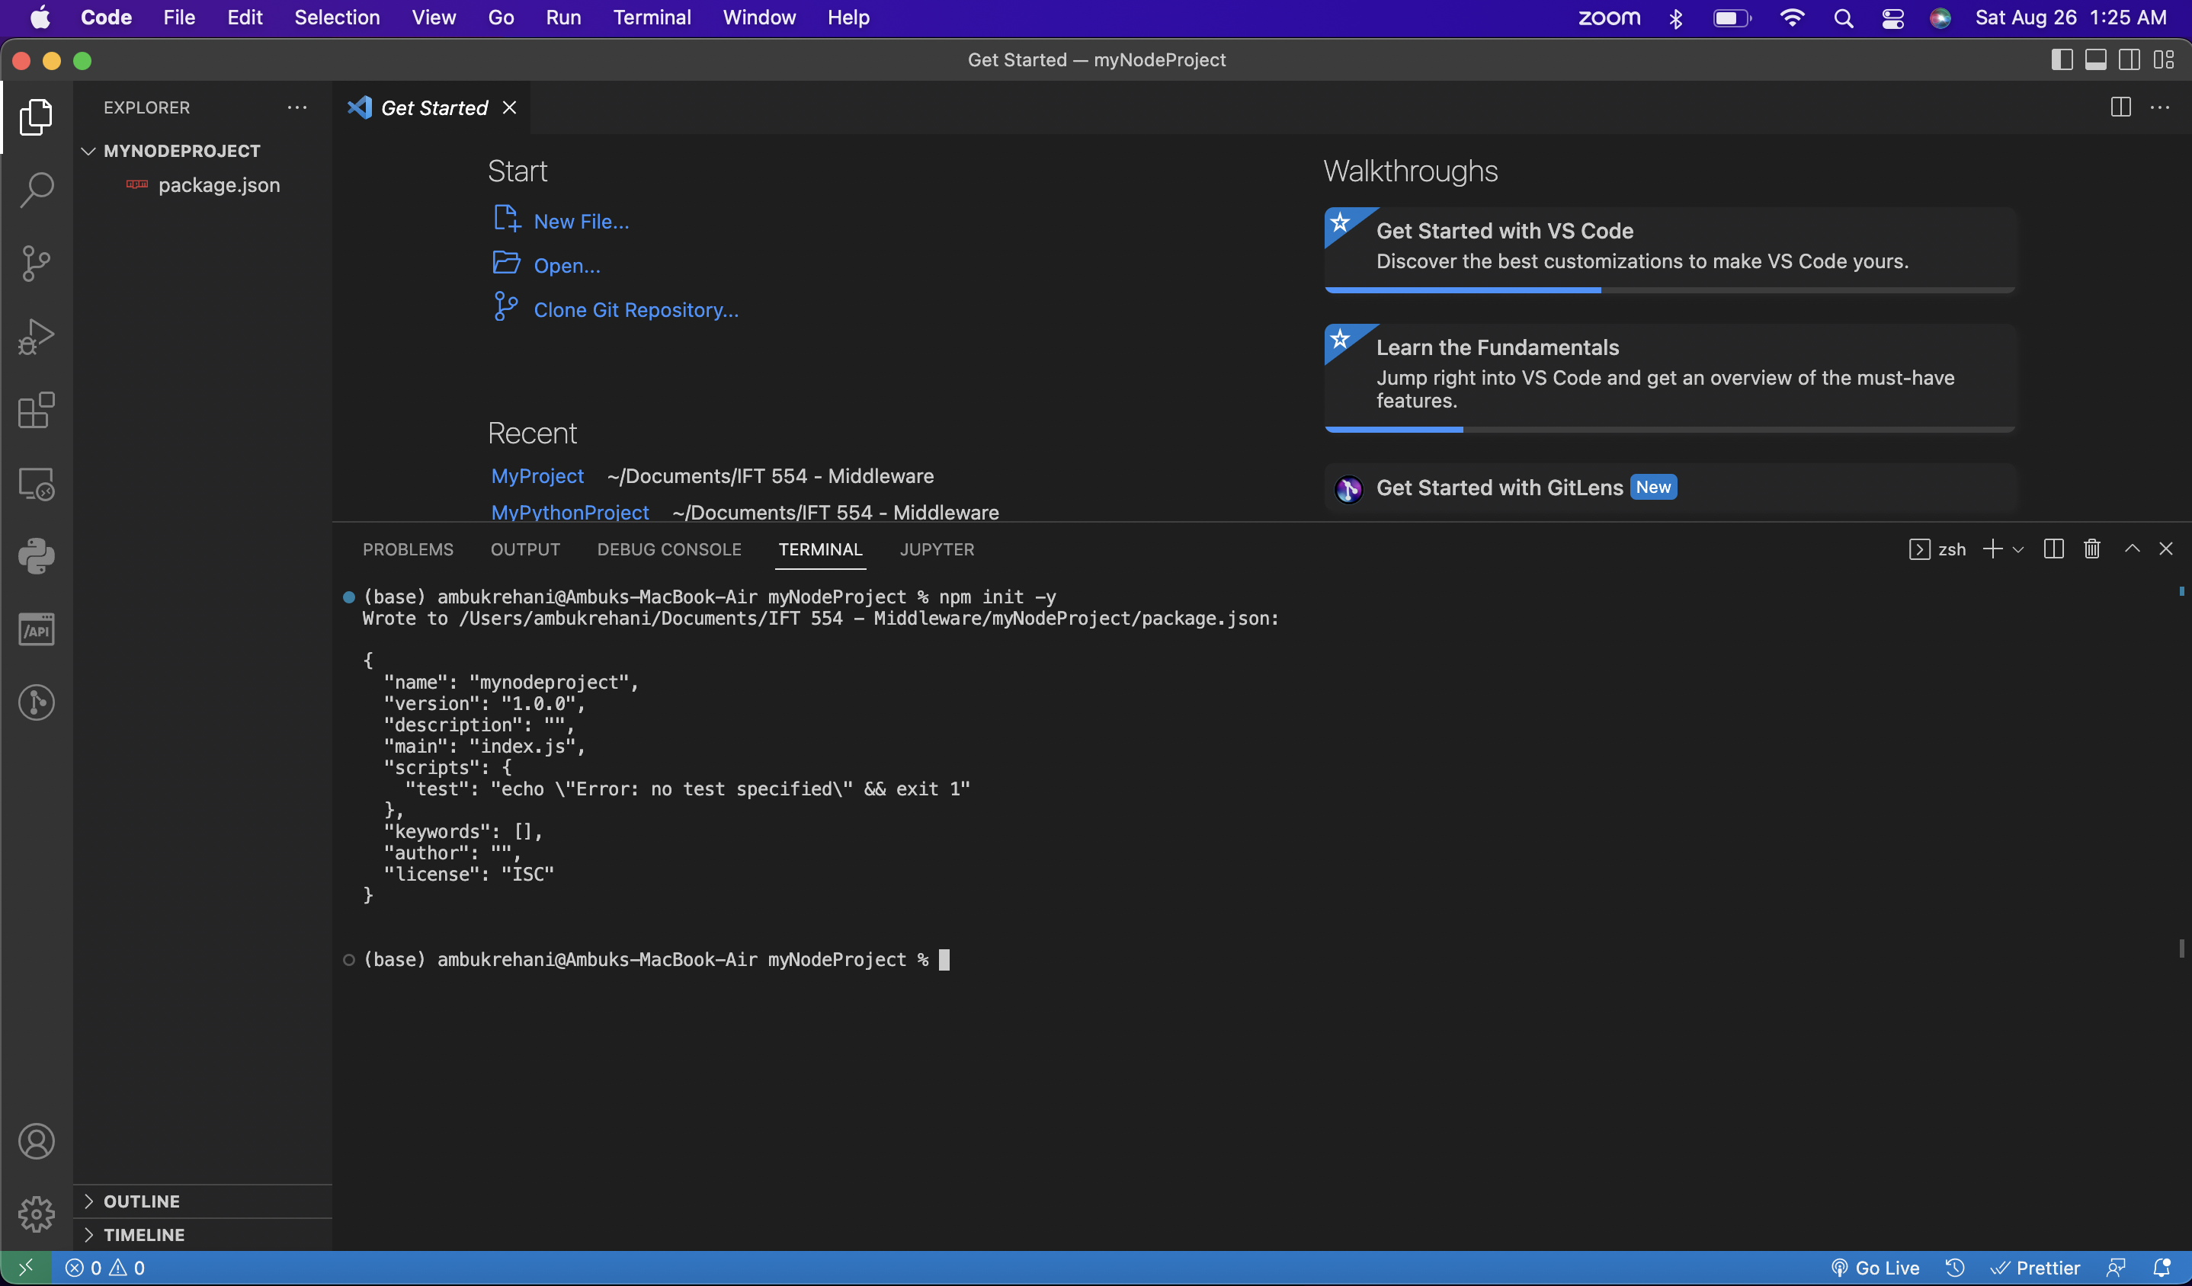

**Step 2: Install Express.js and EJS:**

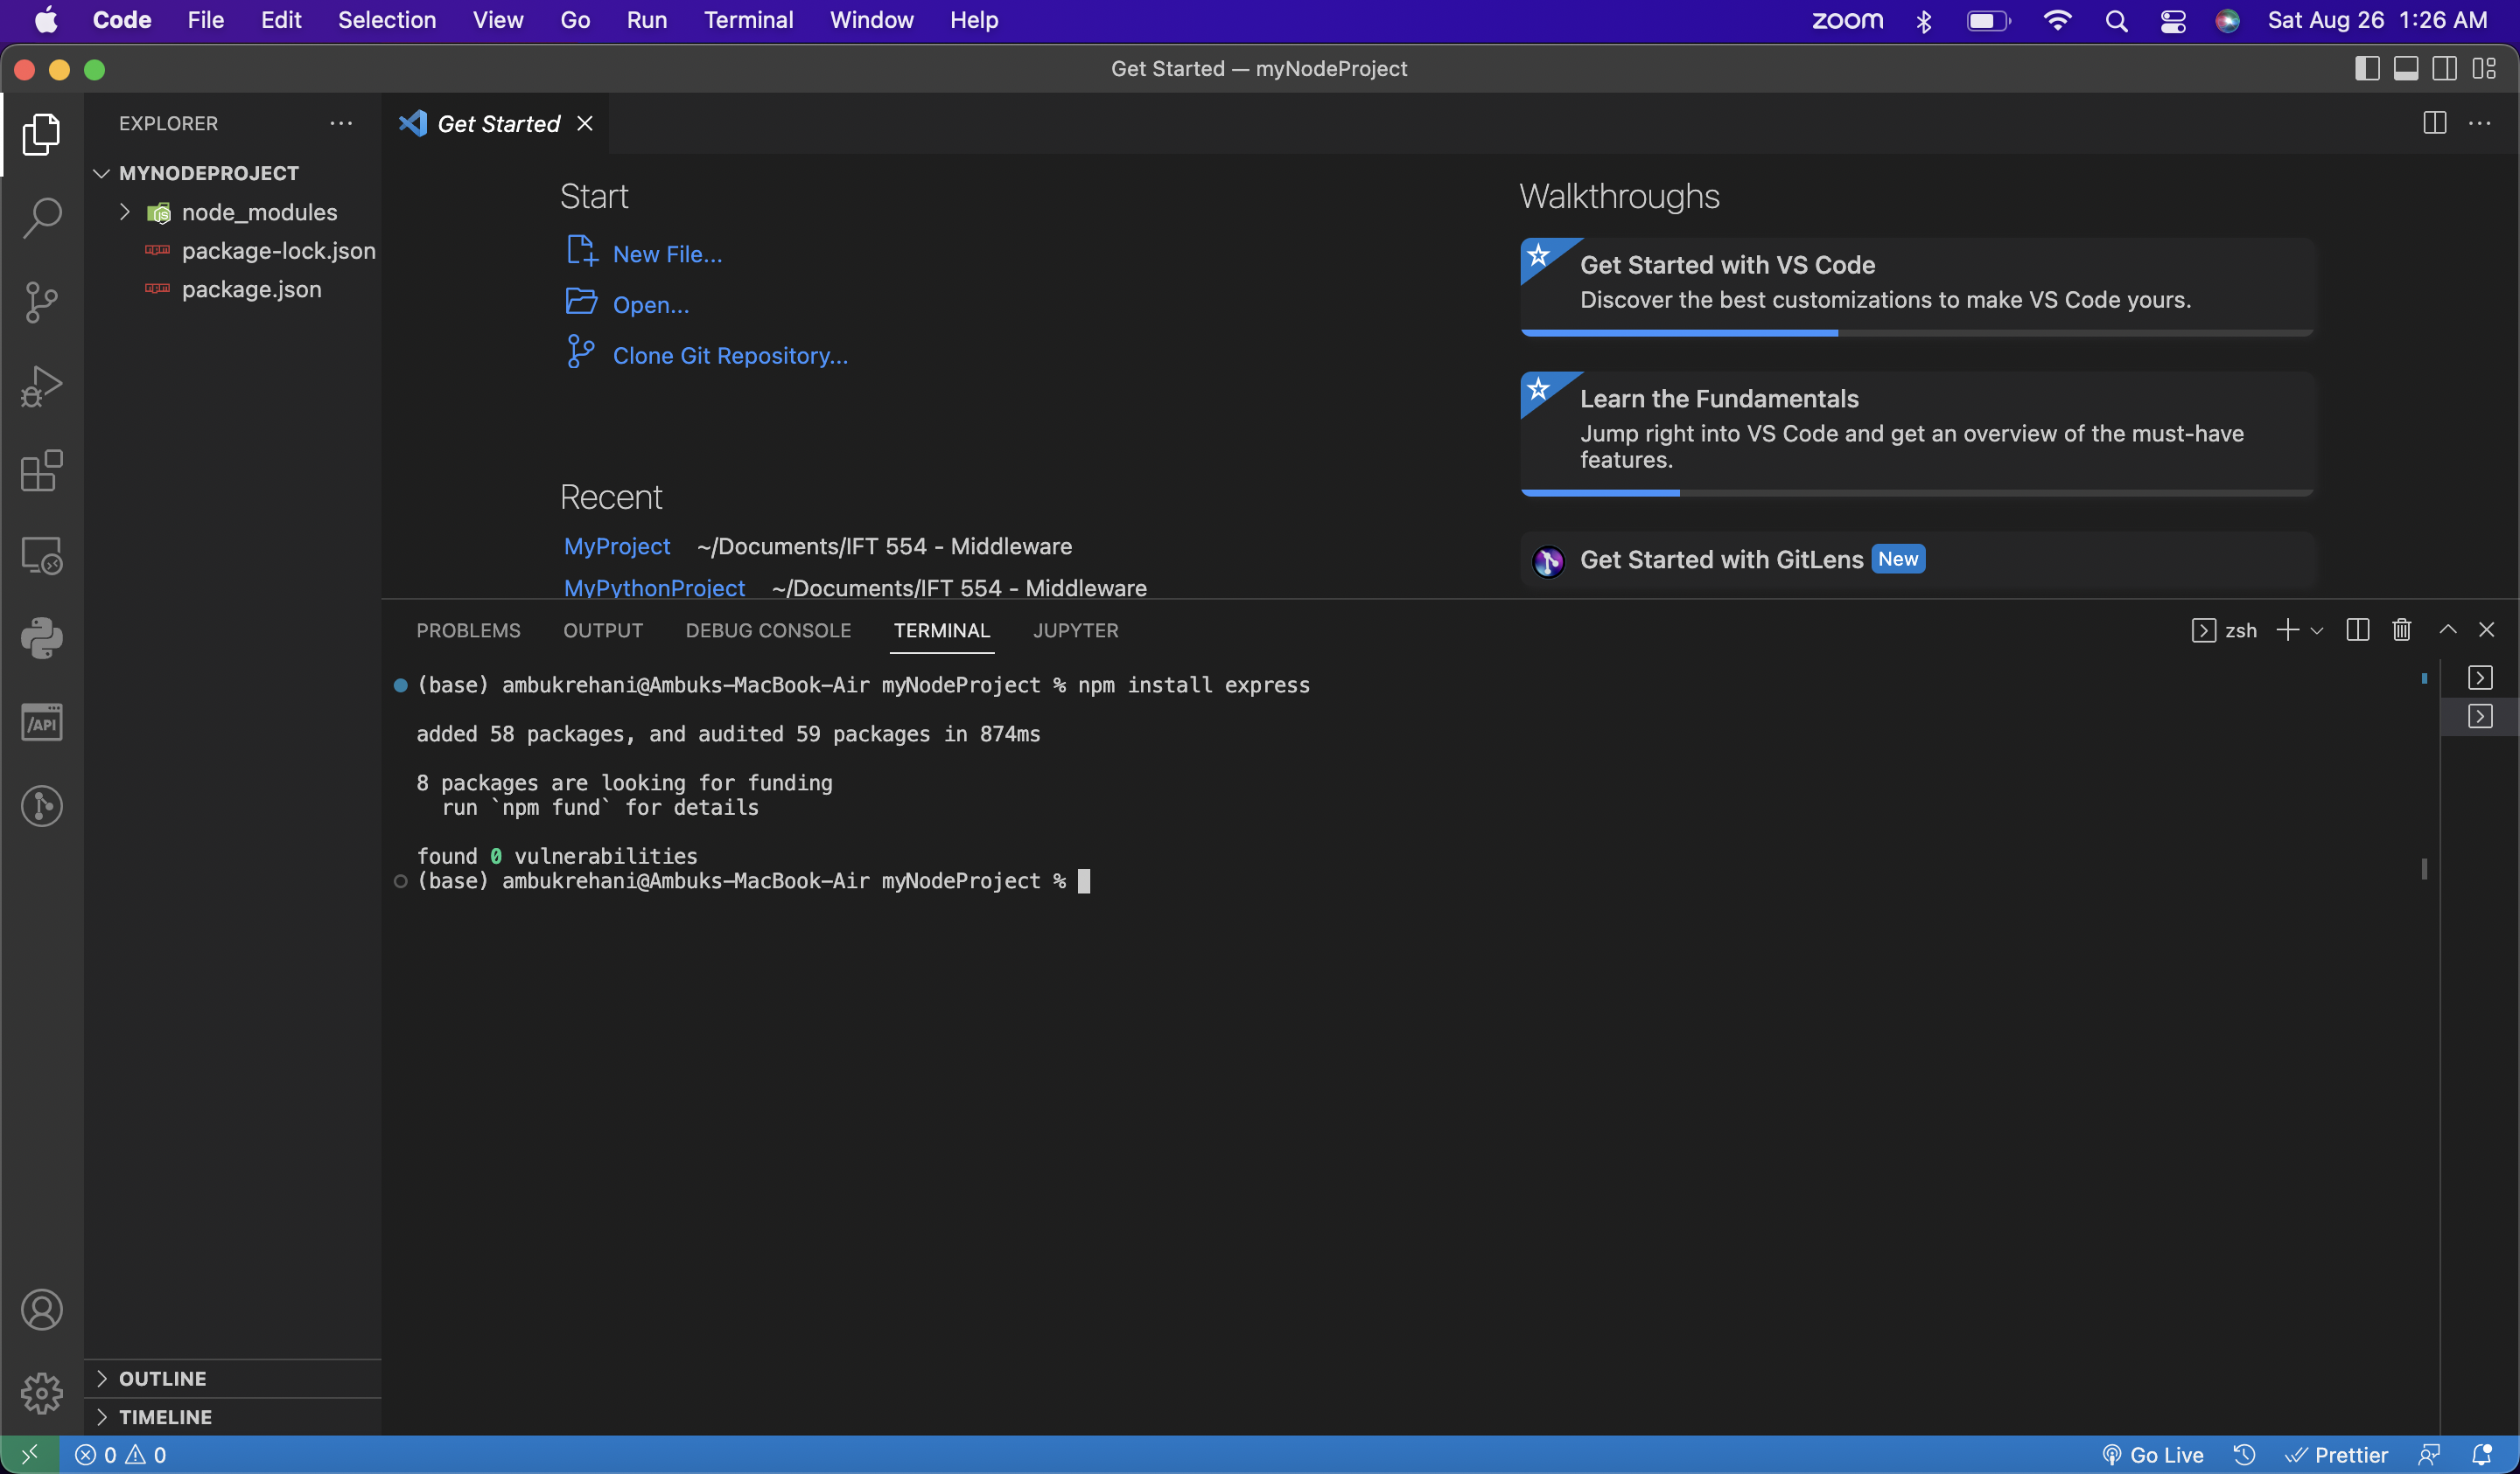

**Step 3: Setup your Express.js Server:**

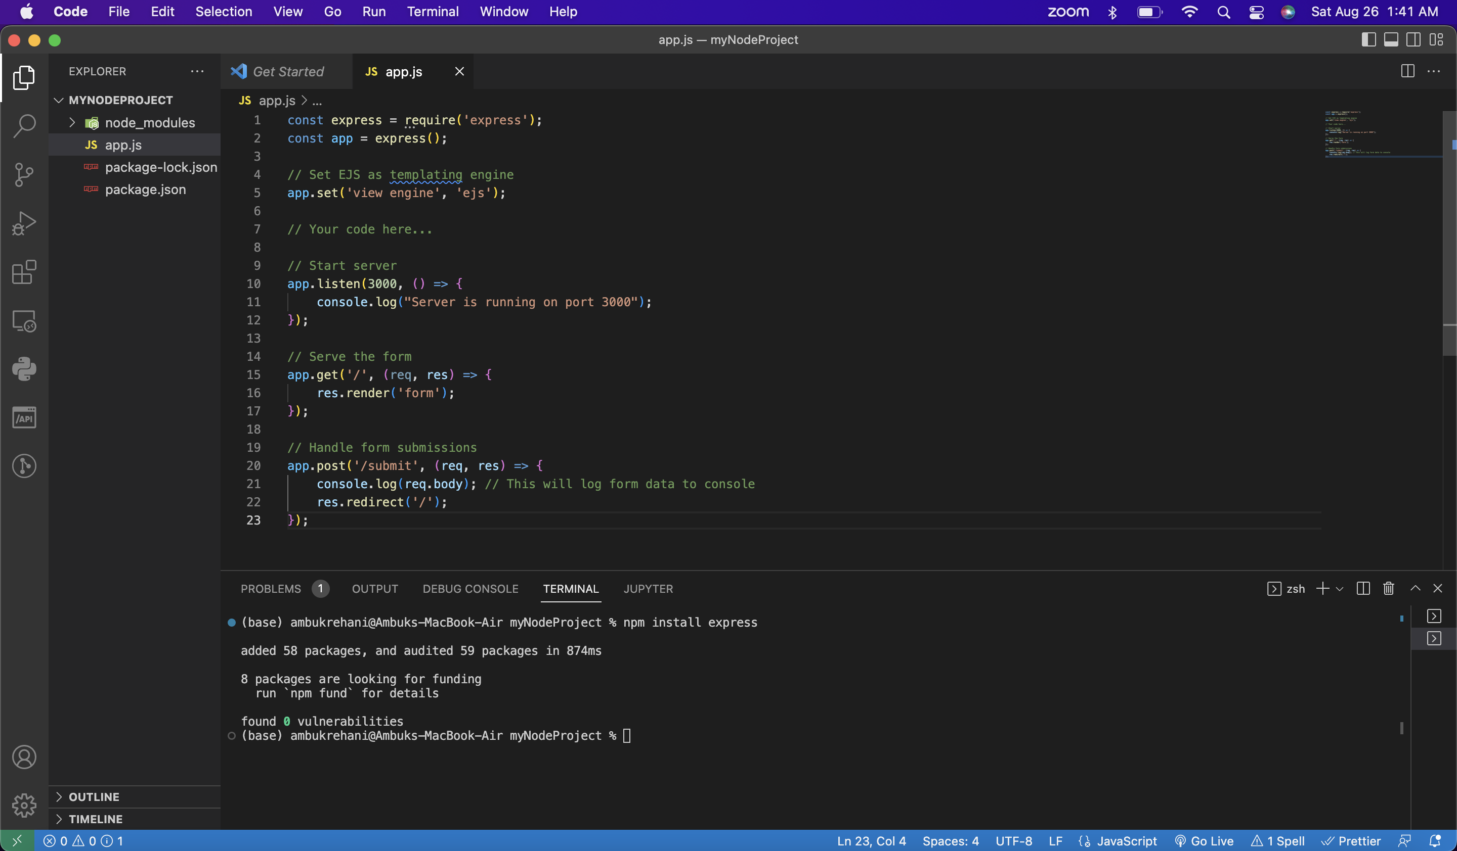

**Step 4: Create your Form:**

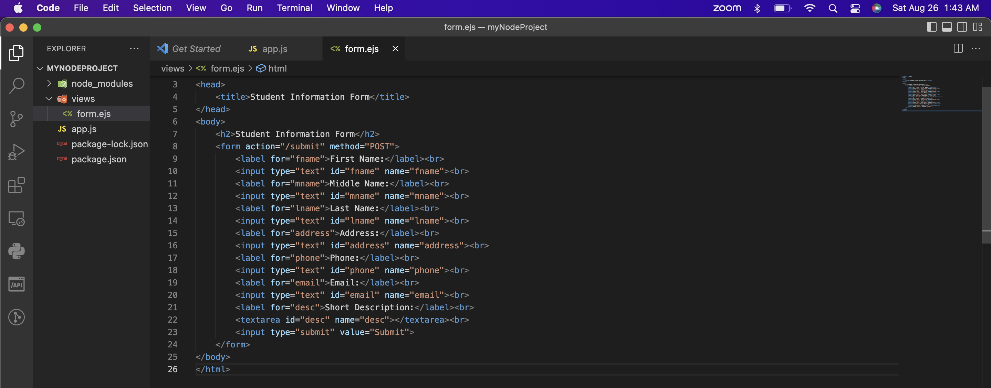

**Step 5: Handle Form Submissions:**

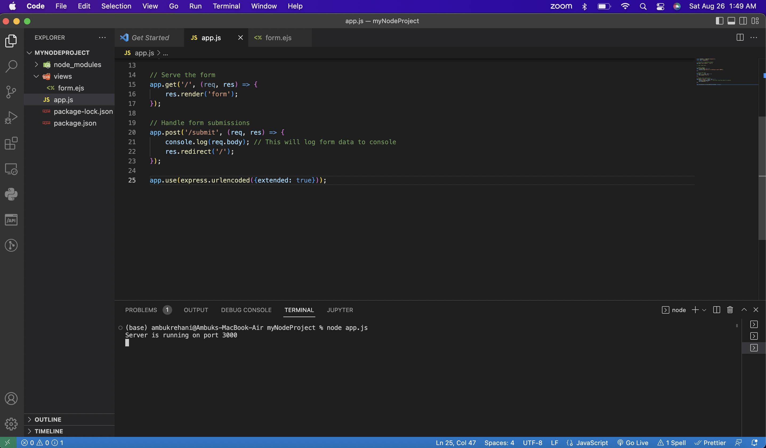

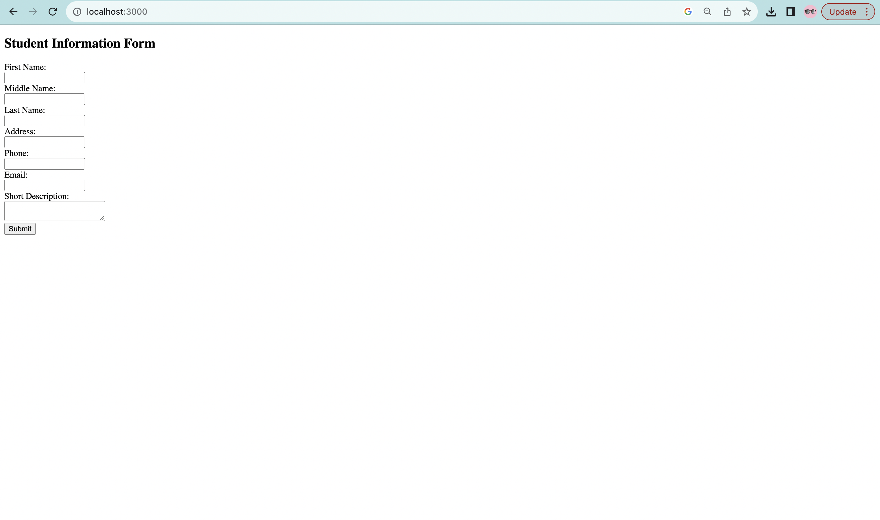

**Step 6: Create Server-Side Function to handle form submission**

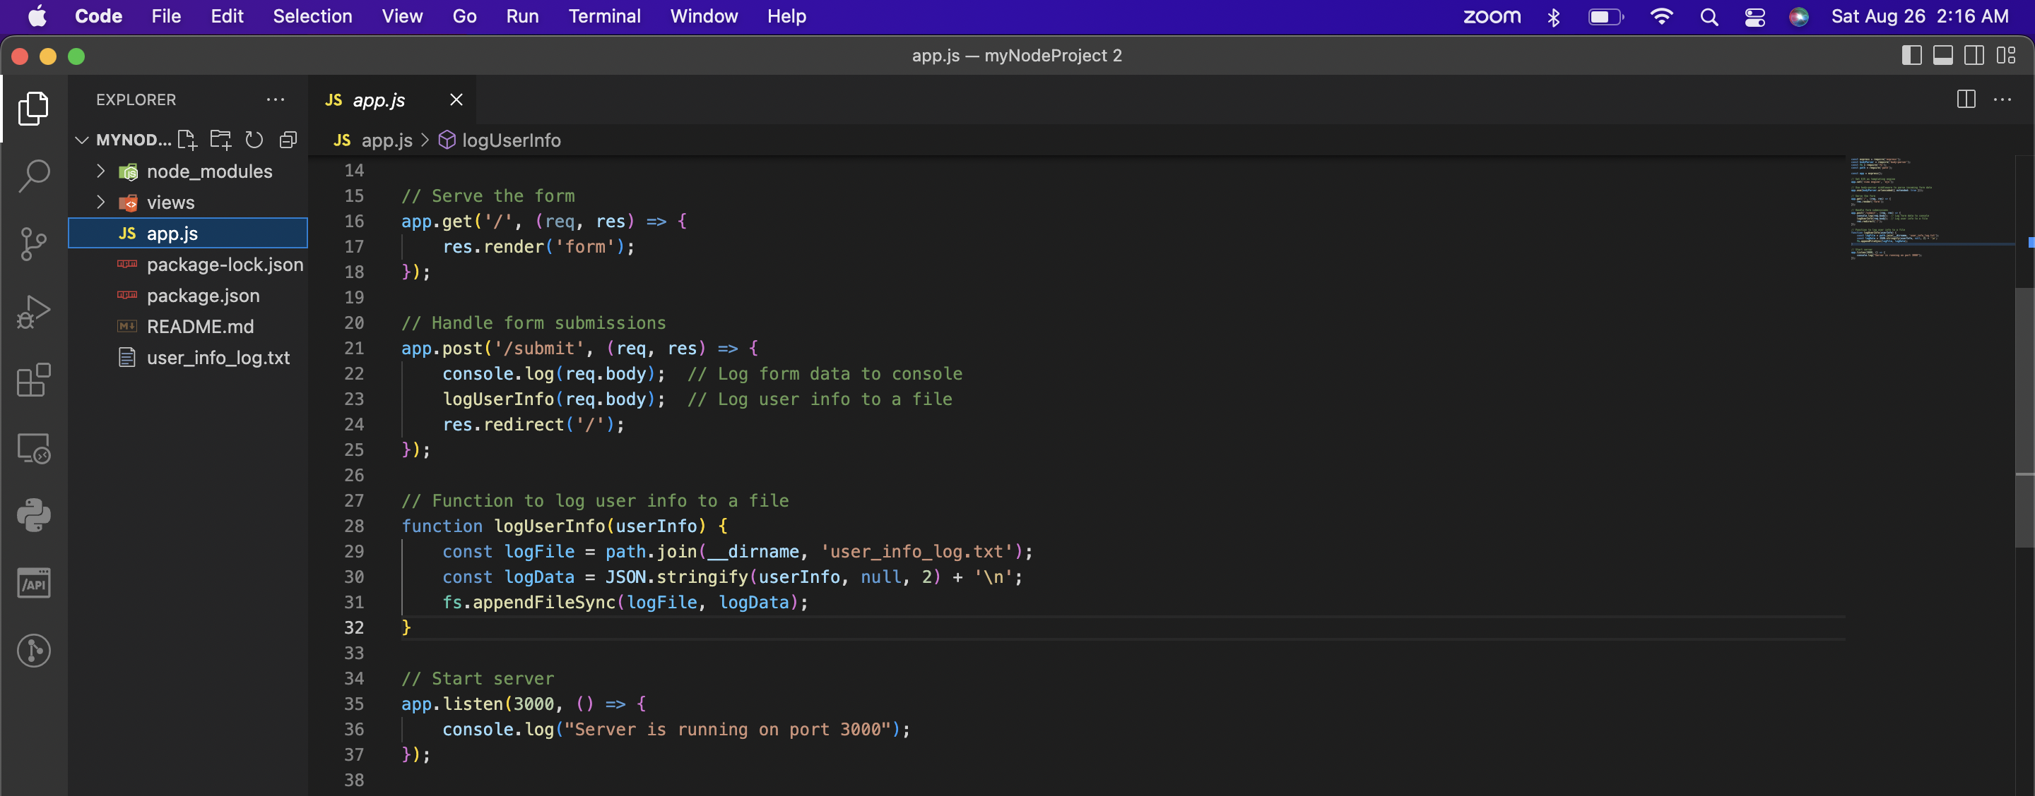

**Step 7 : Function to log user info from the browser to the server-side and save it to a file**

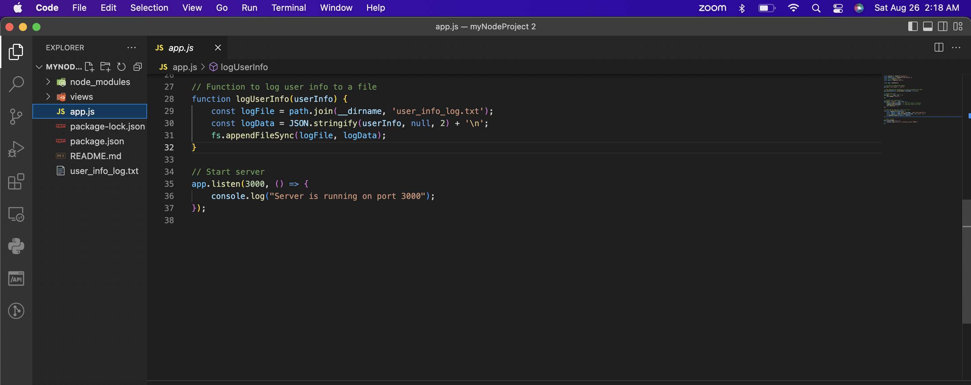

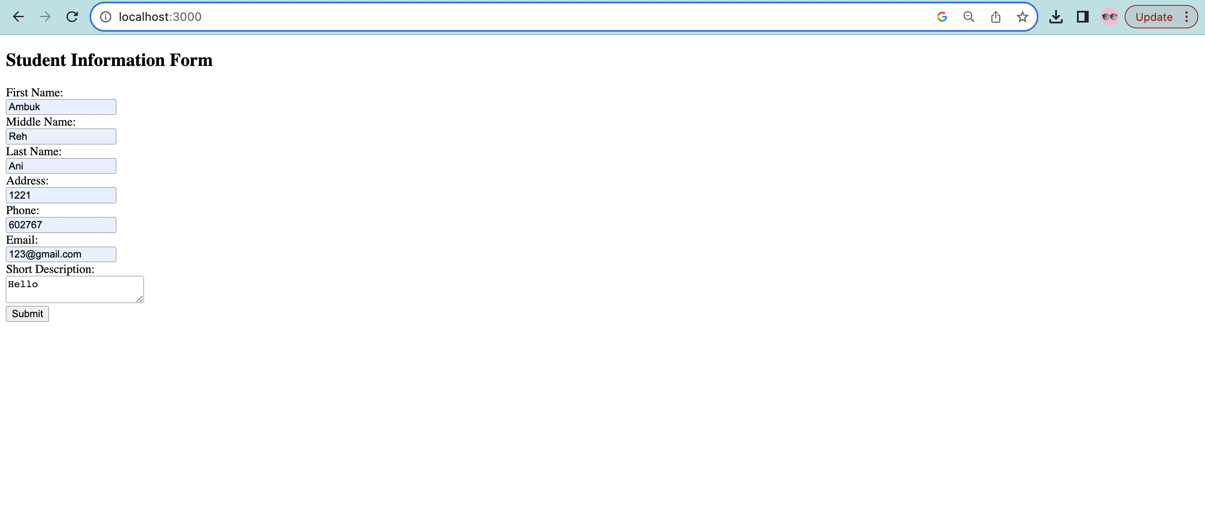

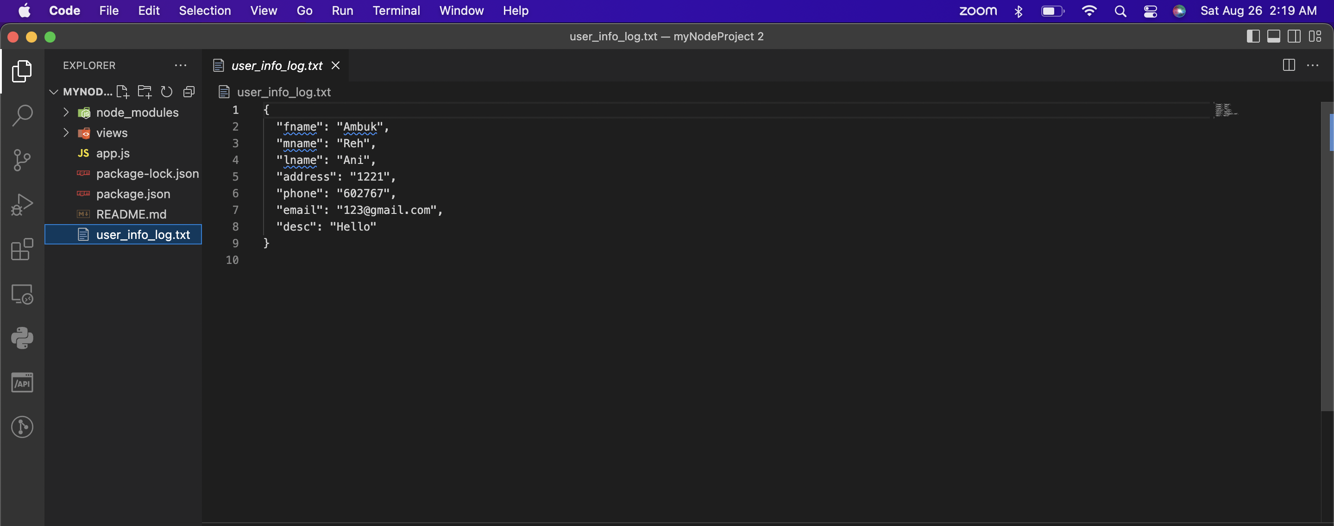

**Step 8 : Documentation**

